27 November 2020
National Food Safety Agency
Status: Confidential
Dear EU regulatory team,
We need your urgent advice! We are Seastar, the producer of the Seaweed Salad, and we have reason to suspect that there is norovirus (GI & GII /25g) in our frozen seaweed salad that has been shipped and distributed to retailers across Europe at the beginning of November. What should we do?
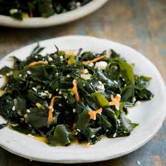
More generally, it seems that we find it much harder to deal with viruses rather than bacterial contamination in our food. Is that something you can support when you look at the legal framework, and perhaps also the coronavirus?
Thank you very much for your valuable help on this!
The executive unit

